1. π class,country (σ (bore≥ 16) Classes)

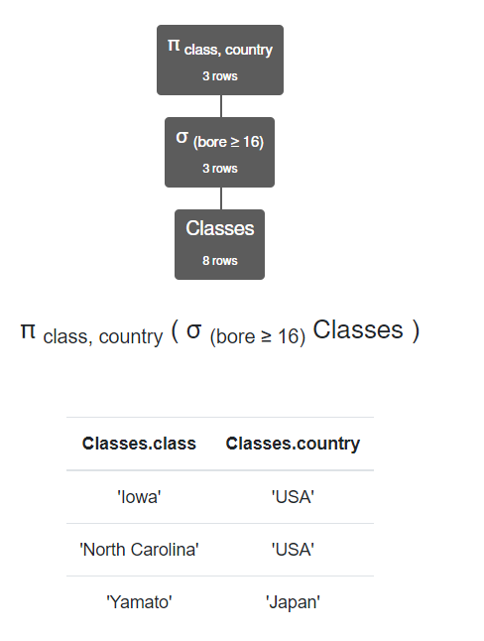

1. π name (σ (launched < 1921) Ships)

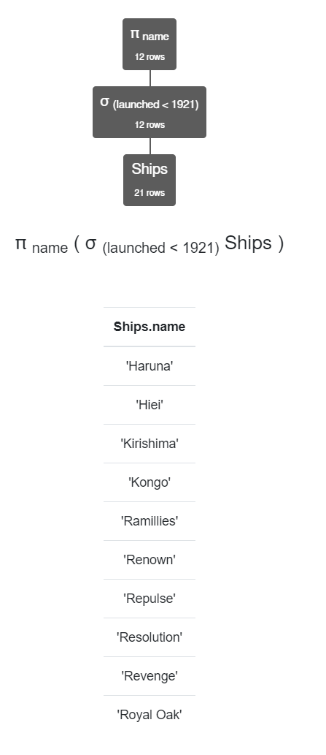

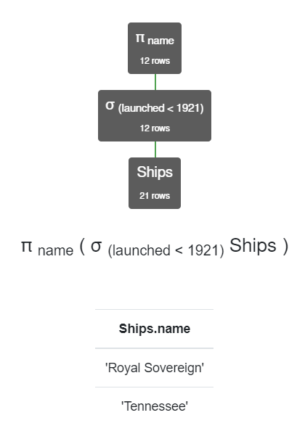

1. π ship (σ (result = 'sunk' ∧ battle = 'Denmark Strait') Outcomes)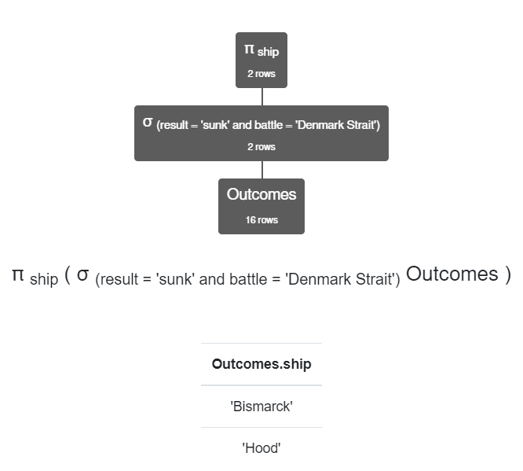
2. π name (σ (displacement ≥ 35000) Classes ⨝ Ships)

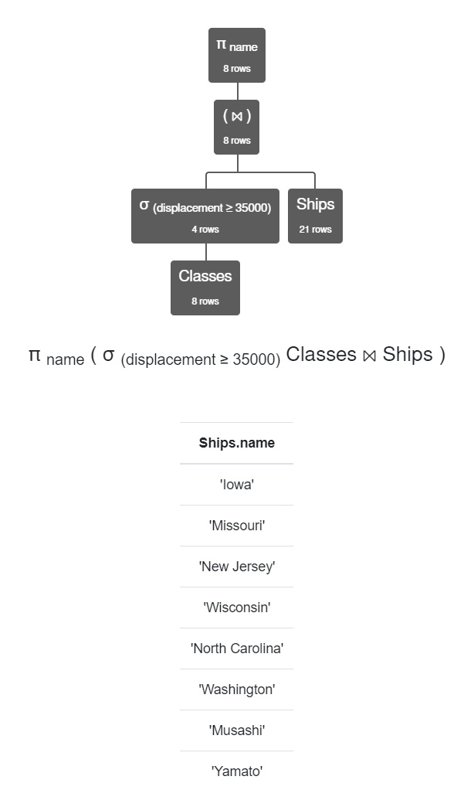

1. π Ships.name,Classes.numGuns,displacement (σ Outcomes.ship = Ships.name ∧ battle = 'Guadalcanal' ((Outcomes ⨯ Ships)⨝ Classes))

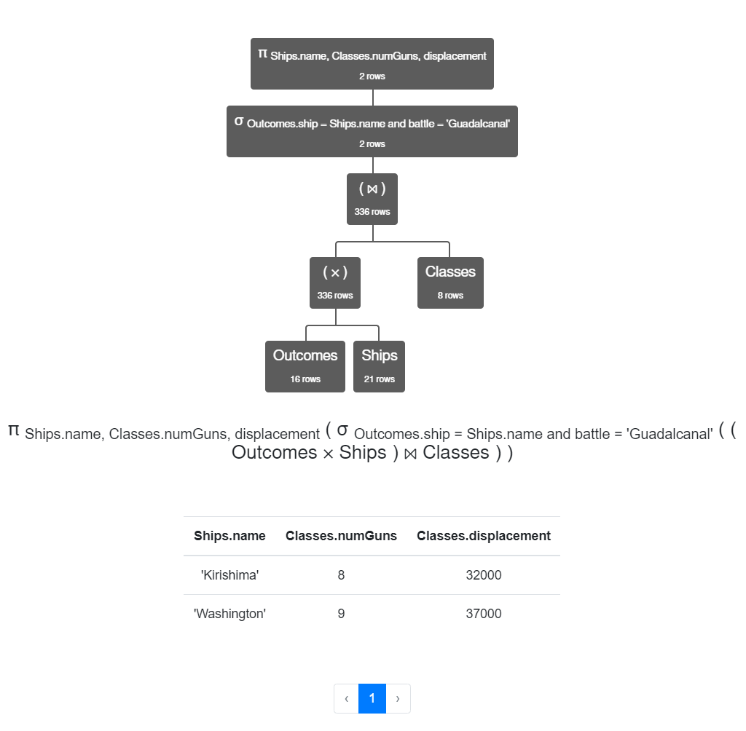

1. π name (Ships) ∪ π class (Classes) ∪ π ship (Outcomes)

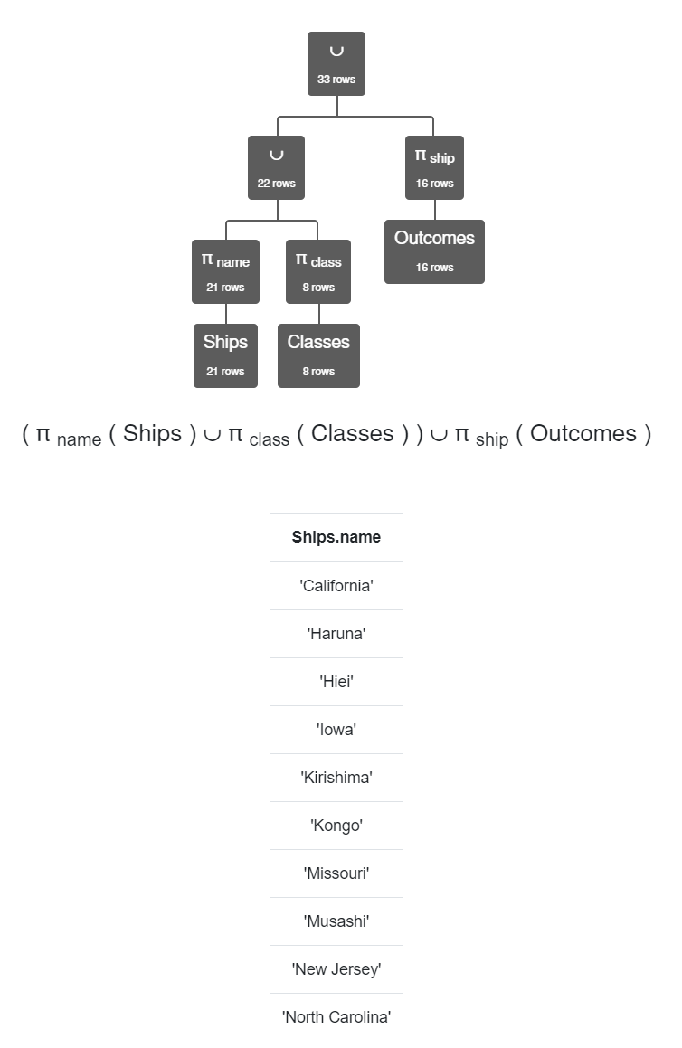

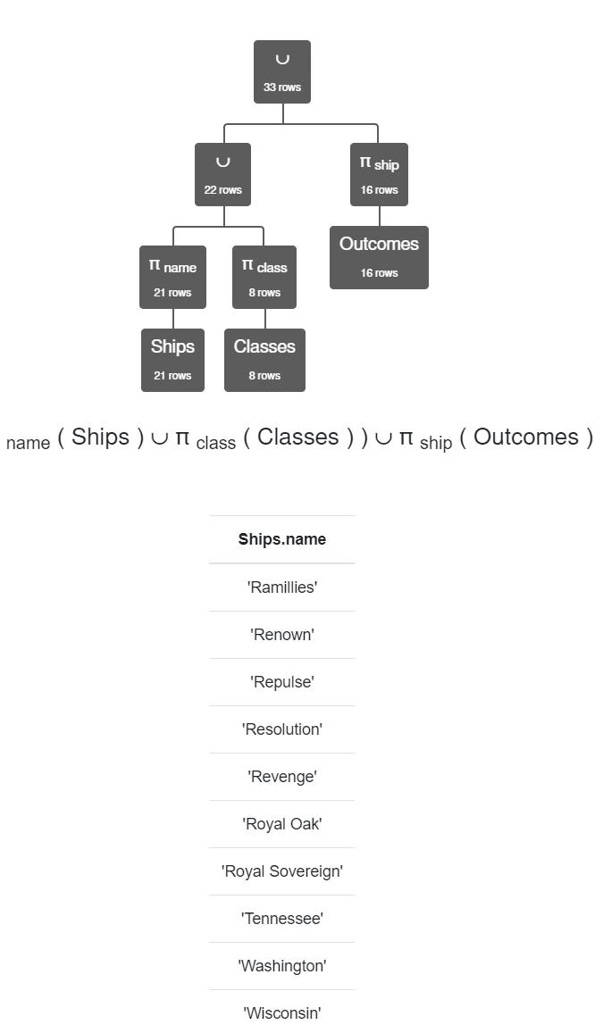

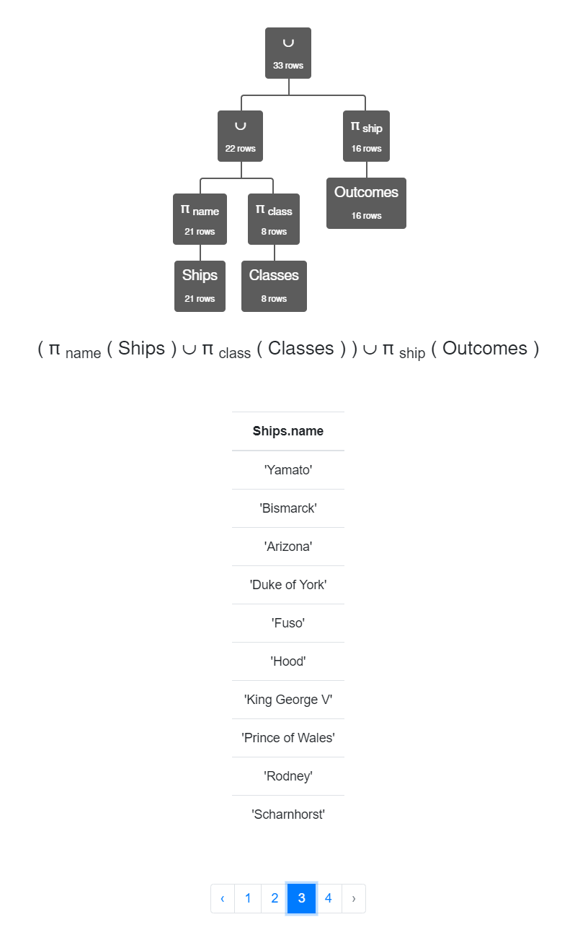

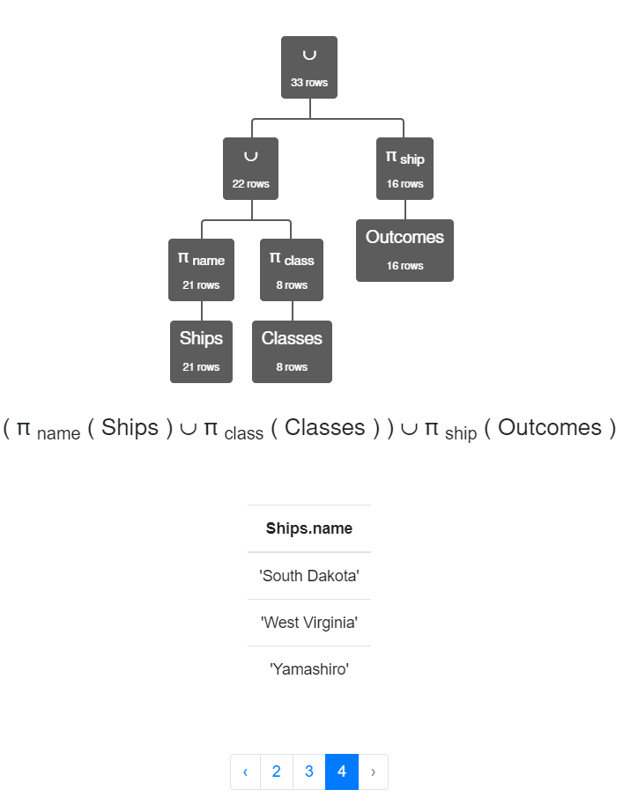

1. π class (Classes) - π name (Ships)

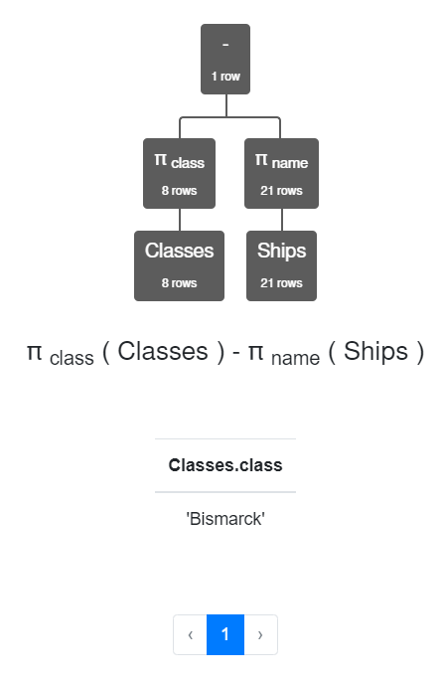

1. π country (σ type = 'bb' (Classes)) ∩ π country (σ type = 'be' (Classes))

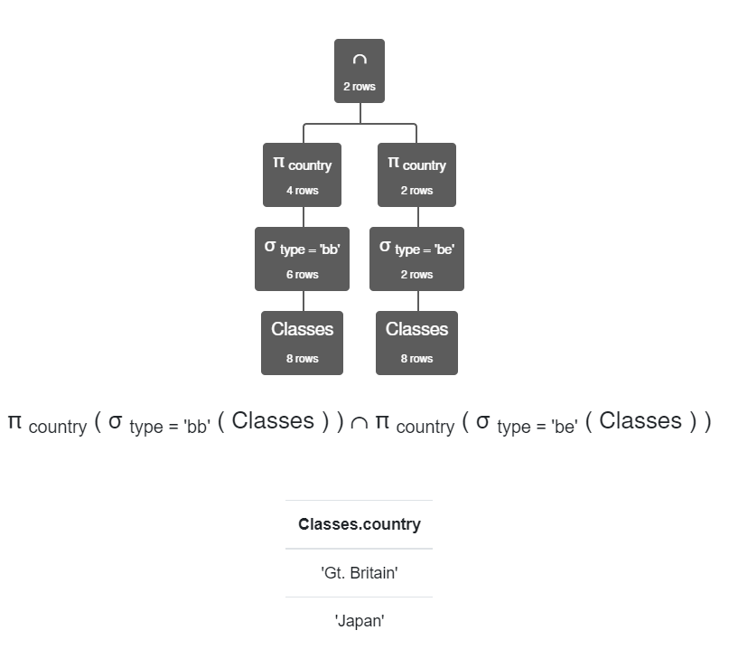

pt2

1. π pizzeria ( σ Frequents.name = Person.name ∧ Person.age < 18 (Frequents ⨯ Person))

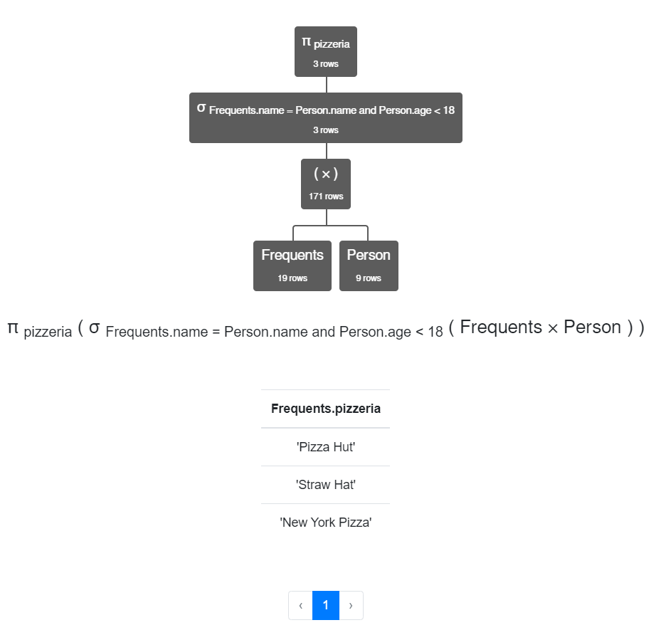

1. πPerson.name ( σ Person.gender = 'female' (Person)) ∩ πname (σ Eats.pizza = 'mushroom' ∨ Eats.pizza = 'pepperoni' (Eats))

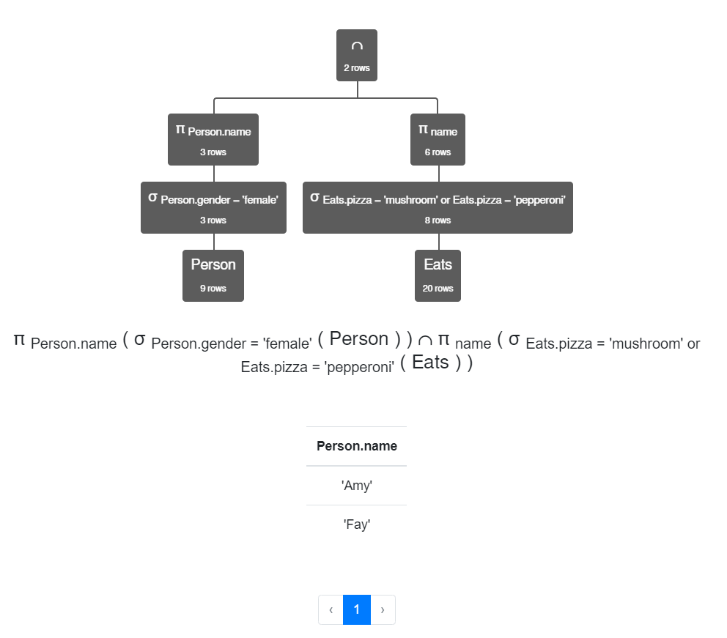

1. πPerson.name ( σ Eats.pizza = 'pepperoni' ∧ Person.gender = 'female' (Person ⨝ Eats)) ∩ πname (σ Eats.pizza = 'mushroom' (Eats⨝Person))

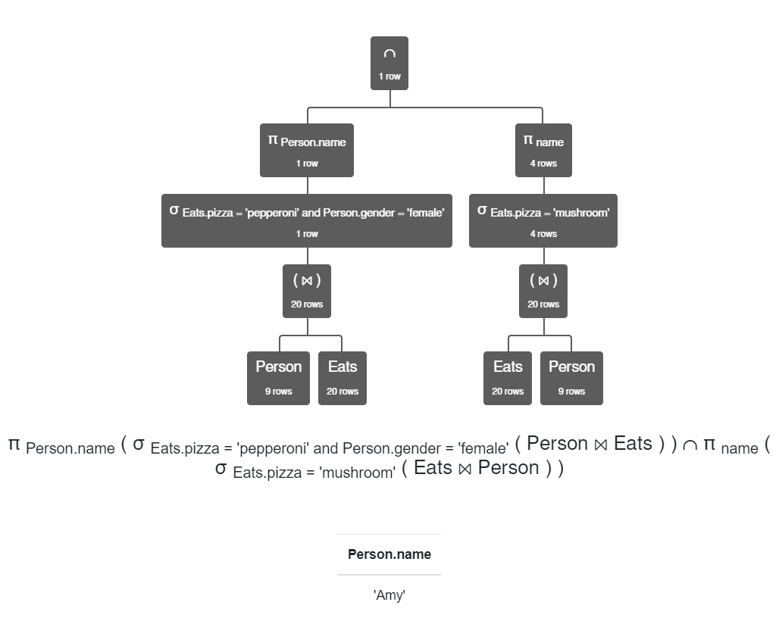

1. π Serves.pizzeria ( σ pizza = 'mushroom' ∨ pizza = 'pepperoni' (Serves)) - π pizzeria ( σ price > 10 (Serves))

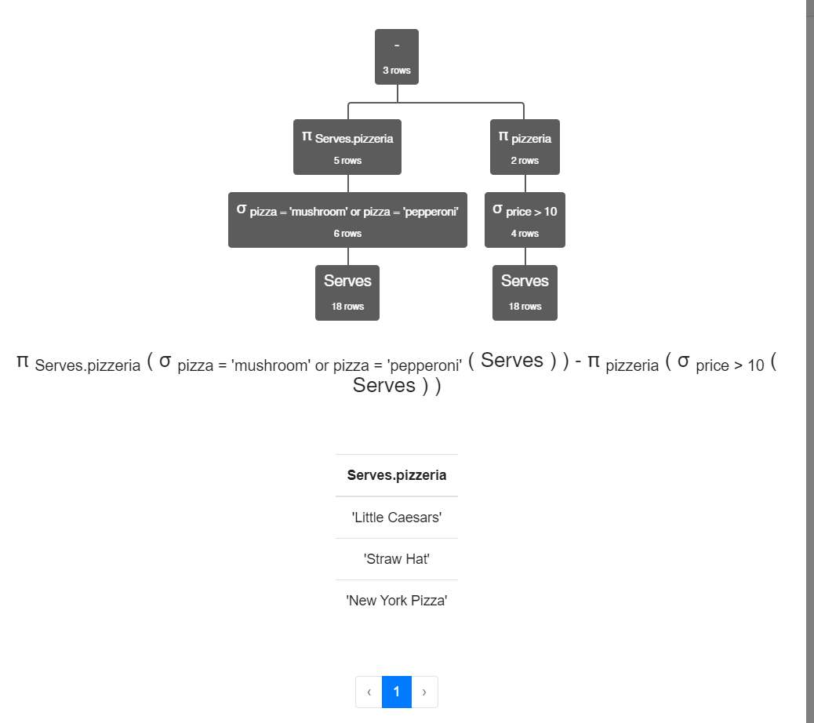

1. π pizzeria (Frequents) - π pizzeria ( σ Person.name = Frequents.name ∧ Person.gender = 'male' (Frequents ⨯ Person)) ∩ π pizzeria ( σ Person.name = Frequents.name ∧ Person.gender = 'female' (Frequents ⨯ Person))

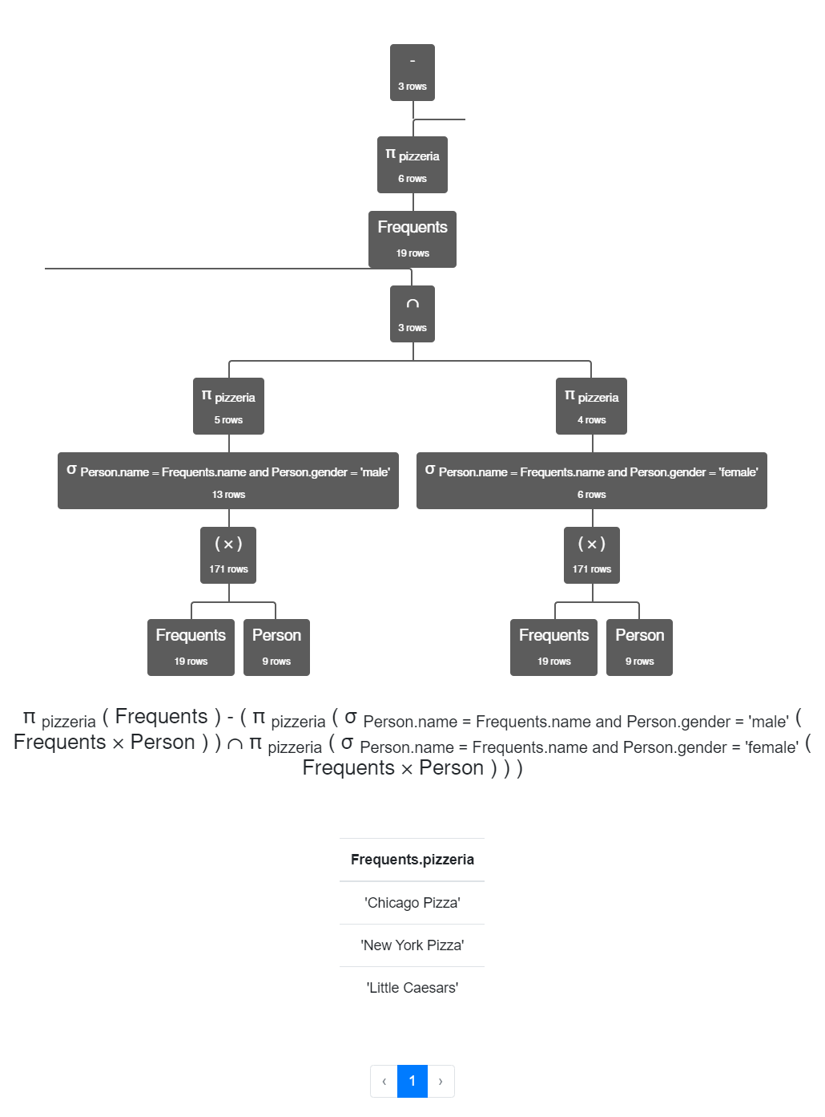

1. Eats - πname, pizza (Frequents ⨝ Serves)

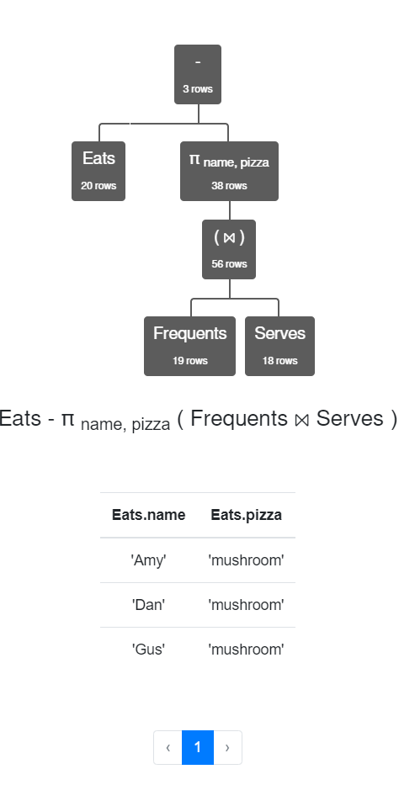

1. π name (Person) - π name ((Frequents) - π name, pizzeria (Eats ⨝ Serves))

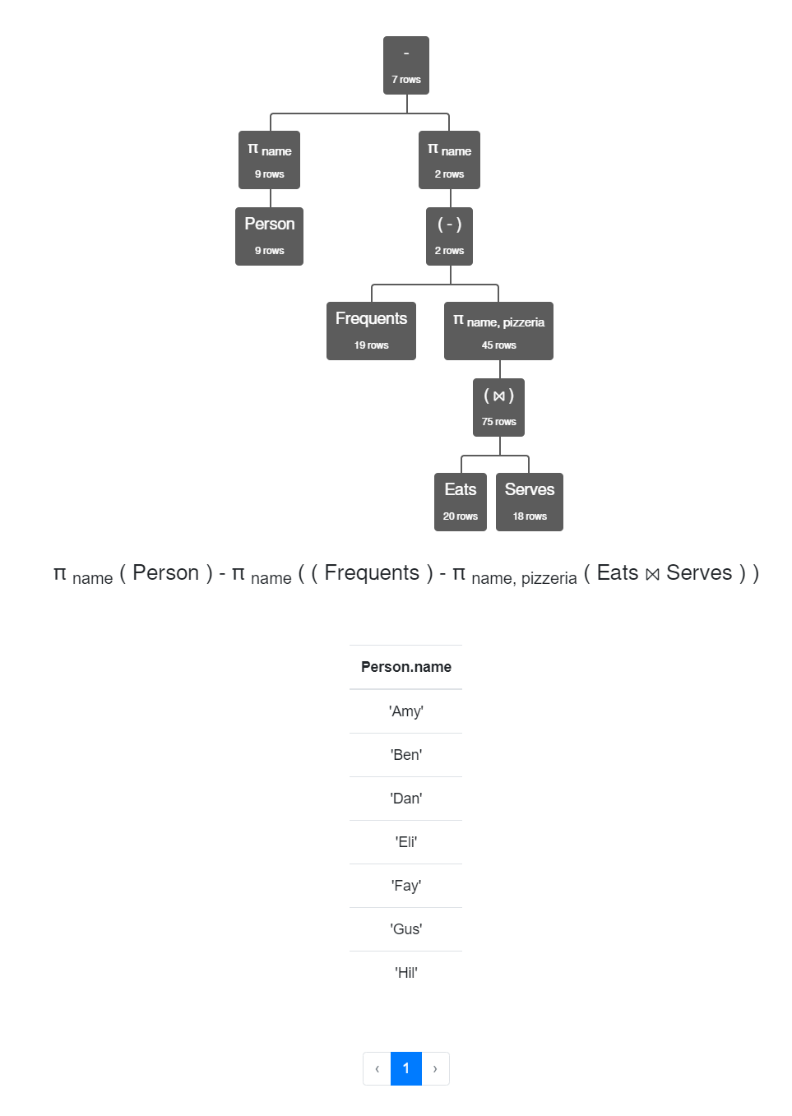

1. πname (Person) - πname (πname,pizzeria ( Eats⋈Serves) - Frequents)

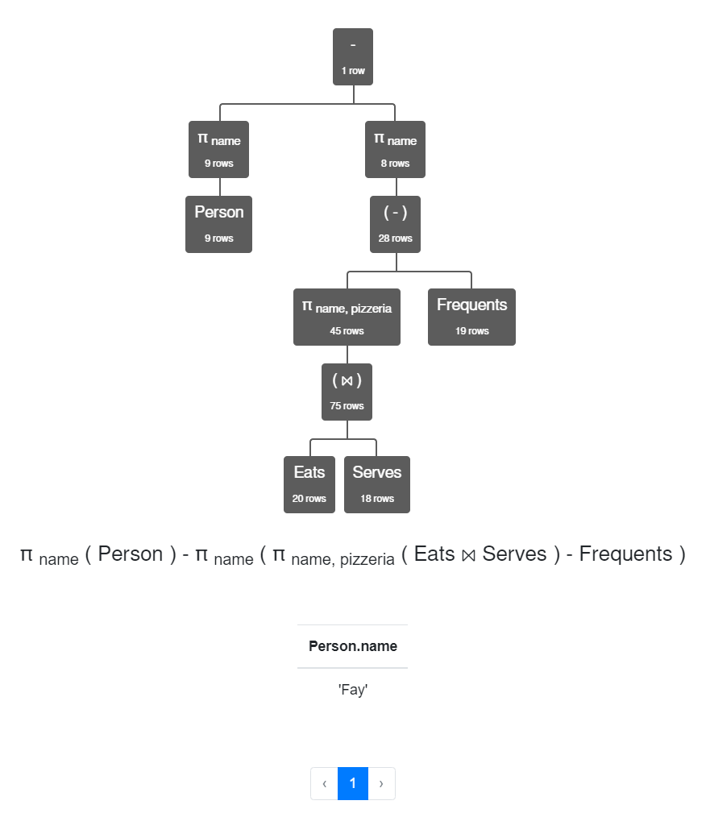

1. π pizzeria ( σ pizza = 'pepperoni' Serves) - π pizzeria ( σ price > price2 ( π pizzeria, price ( σ pizza = 'pepperoni' Serves) ⨯ ρ pizzeria2←pizzeria, price2←price ( π pizzeria,price ( σ pizza = 'pepperoni' Serves))))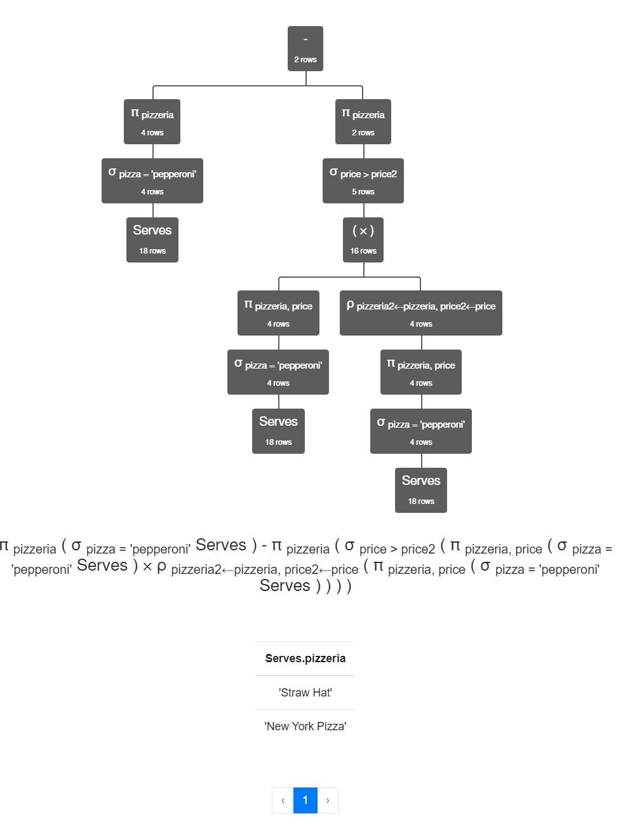
2. πpizzeria,pizza (Serves) ÷ πpizza ( σ Person.age > 30 (Eats ⨝ Person))

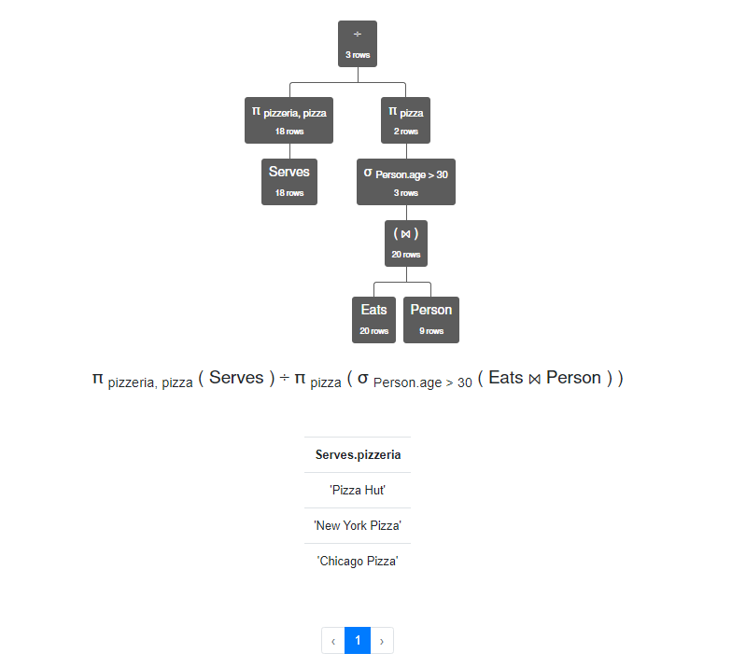

J2) πServes.pizzeria (Serves) - πServes.pizzeria ( πpizza ( σ Person.age > 30 ( Eats ⨝ Person)) ⨯ π Serves.pizzeria (Serves) - πpizza,pizzeria (Serves))

